KACHERE 1 EXAMINATIONS BOARD
2017/18WEEKLY ASSESSMENT
PRIMARY SCIENCE FOR STD 8
(100 MARKS)

SECTION A

SCIENCE

Answer all questions by encircling the right answers A, B, C or D
- Which of the following is not a negative effect of heat energy?
- burns and scalds
- hatching eggs
- loss of property as a result of fire
- making dwelling places uncomfortable

- Mention one function of the human skeleton.
- no movement
- muscles
- Give support to the body
- Give energy to the body

- The following are the reasons for cooking food except __
- to preserve it
- to improve the appearance
- to destroy harmful organisms
- to increase the amount of food

- State two importance of planning meals.
- Saves time and resource
- Improves nutrition and saves money
- It encourages budgeting and hard working
- Promote good habit and hyiegine

- ________ are diseases caused by lack of certain nutrients in the diet.
- marasmus C. nutrition
- kwashiorkor D. nutritional deficiency diseases

- Mention one example of a simple machine.
- school C. screw
- load D. work

- Which part of the plant is responsible for cooking food for the plant
- roots C. stems
- flowers D. leaves

- Why is it important to plan a meal?
- source of meat C. cooking
- it provides more D. saves money

- Give two properties of liquids.
- it flows and have definite volume
- shape and size
- flows and milk
- blood and shape

- Which of the following technologies is responsible for sending both written and spoken messages?
- telephone C. fax machine
- cell phone D. radio

AGRICULTURE

- The following are types of chickens based on use
- eggs and meat C. broilers and layers
- white leg horn and cock D. hen and broilers

- Mention any one disease of ground nuts.
- mice C. red ants
- rosettes D. termite

- Which of the following is a characteristic of a good cock for breeding?
- short and health legs C. small body
- moist vent D. none of these

- Mention any two methods of weeding a woodlot.
- by using hands and hoes
- by applying fertiliser and manure
- by using hoes and applying manure
- by using fertiliser sans slashers

- The following are the management of practices for nursery establishment except ___
- weeding C. watering
- pot filling D. planting

- The following are the products of chicken except __
- eggs B. meat C. beef D. manure

- Mention any one pest of trees.
- blue gum C. termites
- flower D. bees

- The following are methods of irrigation except _______
- sprinkler C. drip
- basin D. river

- The following are common varieties of cassava except ______
- mbundumale C. gomani
- chitembwele D. manipinter

- The following are the common diseases of chicken caused by chorela.
- new castle C. fowl pox
- fowl chorela D. coccidiosis

SECTION B

Answer all questions in this section.

AGRICULTURE (30 marks)
- a) What are farm records
______________________________________________________________________________
b) Explain three uses of water to live stock.
______________________________________
______________________________________
______________________________________
c) Mention two importance of farm records.
______________________________________
______________________________________
- a) Why farmers keep chickens in Malawi? (give two points)
______________________________________
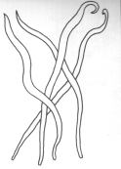
______________________________________
b) The diagrams below are parasites of chickens. Use it to answer questions that follow.

- Name the parasite
______________________________________
- How can the parasite be prevented?
_______________________________________
- Use the figure below to answer the following questions
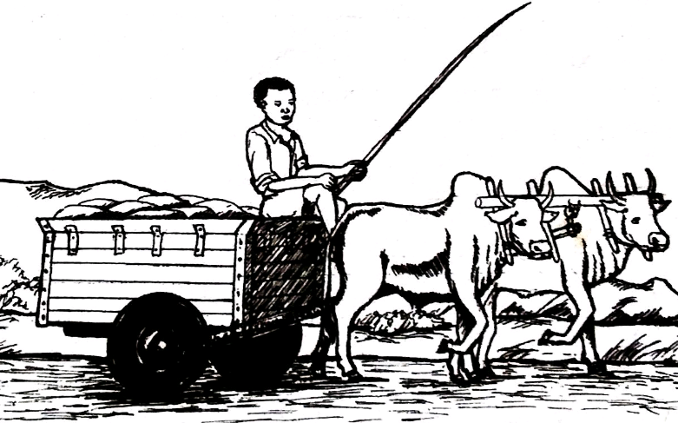
- Describe two ways of maintaining the farm implement shown above
______________________________________________________________________________
b) State any two ways of controlling cough and sneezing in chickens
___________________________________
___________________________________
- a) State any three activities involved in woodlot
management
______________________________________________________________________________
b) State two common methods of weeding.
_______________________________________
_______________________________________
c) State any two common diseases of chickens
_______________________________________
_______________________________________
SCIENCE

- What is a machine?
______________________________________________________________________________
- State the order of the lever machine shown below.
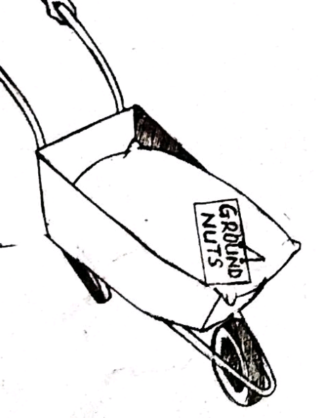
_________________________________________

- Mention any two laundry equipments

__________________________________________

- Study the diagram below and answer the following
questions
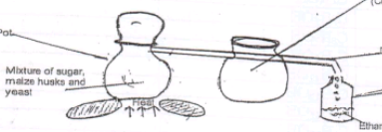

Name the process shown by letter x __________________________________________
Explain how process y is used in every day life __________________________________________

- Give any two common accidents ______________________________________
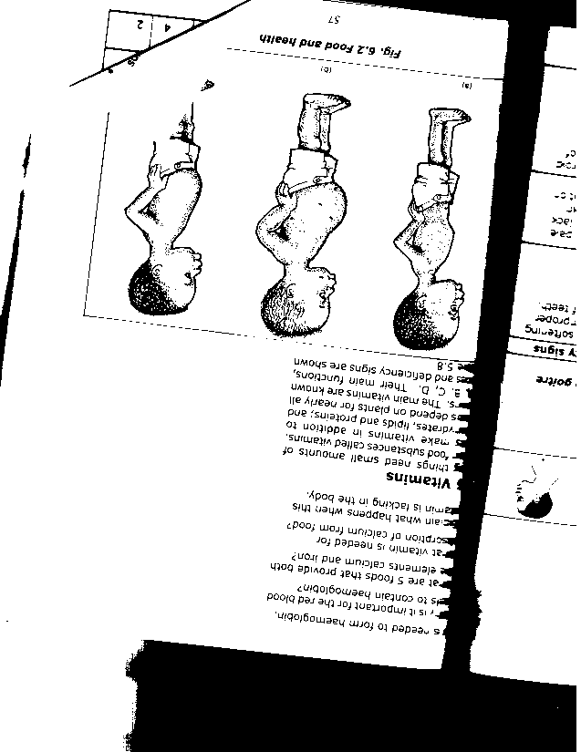
- study the figure below and answer the questions that
follow:

- Name the deficiency disease shown on the figure above
_______________________________________

- List down two signs of the disease.
_______________________________________
_______________________________________
- How can you treat someone with disease illustrated above?
_____________________________________

